Experiment No – 04

Title - Write a program to add digits of a number.

Theory-

Looping Statements in C execute the sequence of statements many times until the stated condition becomes false. A loop in C consists of two parts, a body of a loop and a control statement. The control statement is a combination of some conditions that direct the body of the loop to execute until the specified condition becomes false. The purpose of the C loop is to repeat the same code a number of times.

Types of Loops in C

Depending upon the position of a control statement in a program, looping statement in C is classified into two types:
- Entry controlled loop
- Exit controlled loop
In an entry control loop in C, a condition is checked before executing the body of a loop. It is also called as a pre-checking loop. If the condition is not true, then the body of a loop will not be executed, not even once.
In an exit controlled loop, a condition is checked after executing the body of a loop. It is also called as a post-checking loop.

The syntax of the while loop is:
while (testExpression)
{
// the body of the loop
}

Working of While loop-
- The while loop evaluates the testExpression inside the parentheses ().
- If testExpression is true, statements inside the body of while loop are executed. Then, testExpression is evaluated again.
- The process goes on until testExpression is evaluated to false.
- If testExpression is false, the loop terminates (ends).

Flowchart of while loop

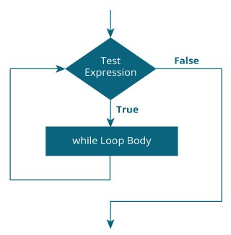

Exercise-
- Write a program to reverse digits of a number.
- Write a program to add digits of a number.
- Write a program to test whether the given number is an Armstrong number.

